

# EXPRESSION OF INTEREST

**District of Squamish Food Trucks**

## BACKGROUND

The District has a vibrant Food Truck Program!

If you are interested in operating a food truck on District land, (including roads, parking spaces, parks, fee simple land) please note the following key guidelines:

* Each food truck operator chooses 1 Primary Spot.
* If a food truck operator would like to be at another operator’s Primary Spot they will coordinate directly with the other operator; In locations where there is more than 1 spot similar food offerings will not be permitted.
* Operators can change their Primary Spot at any time to another spot that is available by providing a written request to the District.

Join the movement!

1. **PROJECT CONTACT** (for inquiries, clarification, submission):

Sarah

Real Estate Coordinator

Phone: 604-848-9088

Email: [realestate@squamish.ca](mailto:realestate@squamish.ca)

## DISTRICT REQUIREMENTS

The following will be required by the selected operator(s):

* + Operators must have a mobile, self-contained unit that shall be removed at

the end of each day.

* + No permanent structures and/or accessories to the food truck will be allowed.
  + Signage must be in accordance with the Sign Bylaw.
  + Operators must have all valid permits and licences required. This includes a District of Squamish Business Licence ($130). As part of the Business Licence approval, Vancouver Coastal Health will review and approve the prospective operators’ plans.

to provide washroom and handwashing facilities to employees.

* + Operators need to have $5 million Commercial General Liability coverage and

$2 million Automobile Insurance. The District of Squamish needs to be named

as an additional insured on the Commercial General Liability insurance.

* + Operating hours must be in compliance with the Noise Bylaw (between 8am and 10pm).
  + A Licence fee of $1,000 for 1 Primary Spot and use of all non-primary spots (subject to

capacity and other restrictions in certain locations). Licence fee will be prorated based on start date.

* Locations
  + See Appendix A for Excluded Locations
  + Check with Real Estate regarding Primary Spot Options
* Term
  + 1 year
* No services provided.
* Grey Water must be discharged in accordance with the District of Squamish Sewer Use Bylaw

No. 2474, 2016. Operators cannot discharge waste water containing grease into the

sewer system. Waste water much be routed through a grease interceptor, via the

operator’s commissary facility. Alternatively, operators’ Food Trucks should be

equipped with a grease interceptor; there is a discharge facility available at Canadian

Tire, located at 1851 Mamquam Road. The Canadian Tire facility is open from March 1st

to November 30th. Please contact the District’s Utilities Department at (604) 815-6868 if you have any further questions.

## EOI SUBMISSION REQUIREMENTS

Respondents to the EOI should include the following information in their submission:

* + Contact Details
  + Primary Spot Selection
    - Check in with Real Estate and provide a list of 3 possible Primary Spots in order of priority
    - Square footage required
  + Waste Management Plan (must be in compliance with the Wildlife Attractant Bylaw)
  + Detailed summary of the food menu, please include items, descriptions, prices, etc. (full copy of the menu can be attached).
  + Grey water management plan
  + Qualifications/History of the business
  + Pictures of the Food Truck
  + 2 References

The successful respondent(s) will be required to enter into a licence with the District and

demonstrate it has the financial resources and appropriate insurance to fulfill the requirements.

of the agreement.

## SUBMISSION CLOSING DATE

The submissions for this EOI are ongoing at this time. The proposal must be sent.

by email to:

Sarah

Real Estate Coordinator

Phone: 604-848-9088

Email: [realestate@squamish.ca](mailto:realestate@squamish.ca)

1. **EOI EVALUATION CRITERIA**

EOI submissions will be evaluated based upon, but not limited to, in any particular order, the

following:

* Quality of the Submission
* Competence/Experience
* Menu Diversity/Innovation
* Fit with the location.
* References

Please indicate how your submission meets the evaluation criteria.

1. **CONFIDENTIALITY**

The District will receive all submissions to this EOI in confidence, including for the purposes of

section 21 of the Freedom of Information and Protection of Privacy Act, R.S.B.C. 1996, c.

However, due to the right of access to records created by that Act, the District cannot, and

does not guarantee that information contained in any submissions will remain confidential.

if a request for access in respect of any submission is made under the Act.

If a respondent considers that any part of its submission is proprietary, including by reason

of it being copyright, the submission must clearly identify those portions that

are considered proprietary.

**On receipt of expressions of interest, the District may: enter into negotiation with**

**some or all of the respondents; or, choose not to continue with this process.**

**No contractual obligations to any party will result from this request of expressions of interest.**

**APPENDIX A**

**EXCLUDED LOCATIONS**

## Adventure Centre Main Parking Lot and Adventure Centre Gravel Lot

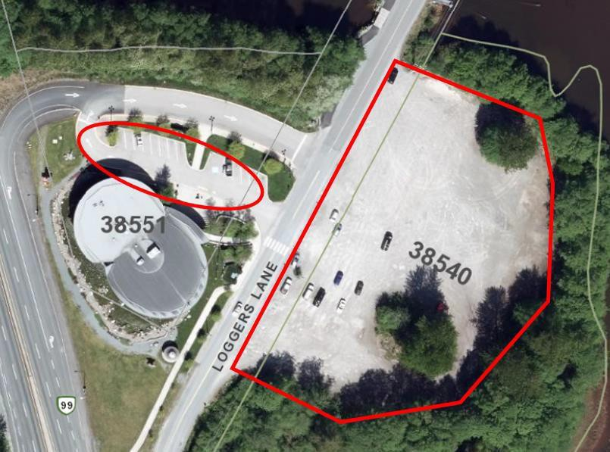

* 1. **Smoke Bluffs Parking Lot**

